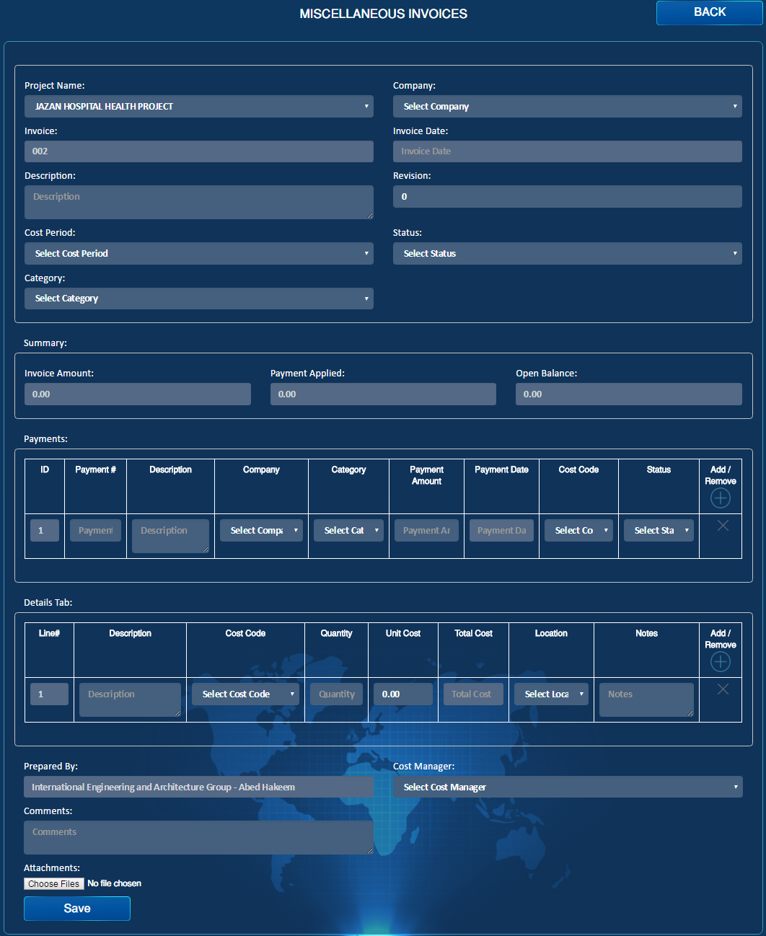

Approve

Import

Reject

Import

Draft

Import

Submit

Import

Transmittal Letter

Import

PDF

Import

Email

Import